Dynatrace Lab: Session Monitoring, Dashboarding, and Alerting

Objective
In this extended lab, you will:
- Analyze user sessions and frontend/backend services using Dynatrace
- Create custom dashboards to visualize performance
- Set up alerts for anomalies or threshold breaches

Pre-requisites Recap
Make sure the following from the previous lab is complete:
- EasyTravel app running via Docker
- Dynatrace OneAgent installed on the EC2 instance
- Containers detected in Dynatrace

1. User Session Monitoring (RUM - Real User Monitoring)
EasyTravel web app supports RUM (Real User Monitoring) out of the box when running with Dynatrace OneAgent.
Steps:
- Log in to Dynatrace.
- Go to "Applications".
- Locate “EasyTravel Angular” or similar frontend service.
- Click on it to open the application overview.
Analyze:
- Real user sessions and synthetic sessions
- User actions (clicks, navigation)
- Bounce rates, load times, performance breakdown
Screenshot Placeholder:
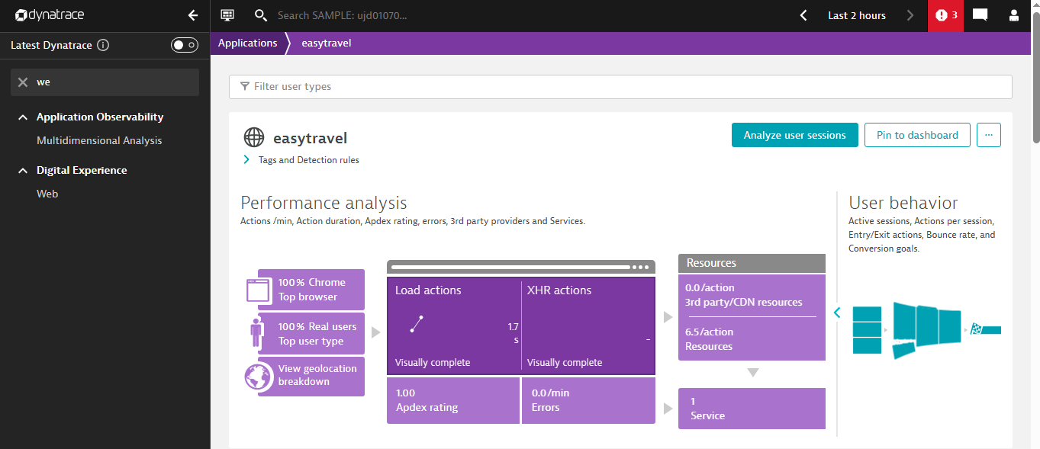

2. Frontend & Backend Service Analysis
Frontend (Angular or Web frontend):
- Go to Transactions & Services
- Search for the frontend service (e.g., angularfrontend)
- Explore:
  - Requests per minute
  - Response time distribution
  - Failed requests
  - Service flow map
Backend (Business logic or REST API services):
- Identify Java services like BusinessBackend, PaymentService, CustomerFrontend, etc.
- Click each to view deep-dive:
  - Methods executed
  - Hotspots
  - Database queries
Trace User Action to Backend:
- From the user session → click on an action → “View PurePath”
- See full trace: Frontend → LoadBalancer → Backend → DB
Screenshot Placeholder:

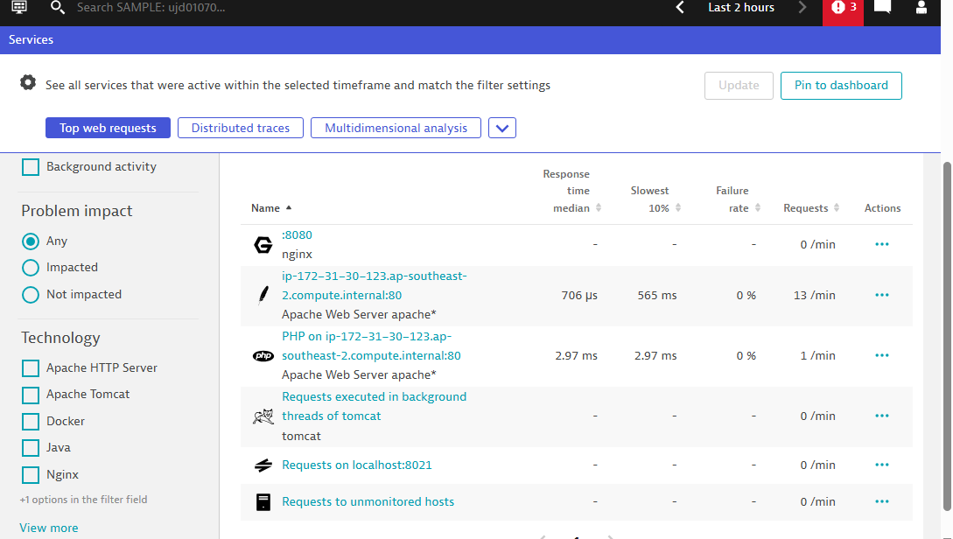

3. Create Custom Dashboard
Step-by-Step: Create a Dashboard in Dynatrace
- Go to Dashboards
  - From the left-hand navigation menu, click on Dashboards.
- Create New Dashboard
  - Click on Create new dashboard (usually top-right).
  - Give your dashboard a name (e.g., "Performance Overview").
  - Optional: Add a description and set sharing options.
- Click on "Add tile" or "+" button to add visualizations.

Add the Following Tiles
- Service Response Time
  - Go to Add tile → choose "Custom chart".
  - Metric: Search for Response time
  - Filter by: Service
  - Aggregation: Average or 95th percentile
  - Visualization: Line chart or bar (based on preference)
- Failure Rate
  - Metric: Failure rate
  - Filter by: Service
  - Aggregation: Average
  - Visualization: Line chart or single value
- Top Services
  - Use Top list tile.
  - Metric: Response time or Throughput
  - Filter by: Service
  - Sort by highest value
- User Sessions
  - Metric: User sessions
  - Scope: All Applications or specific Application
  - Visualization: Single value or timeseries
- CPU / Memory / Disk Usage
  - Add separate tiles for each:
    - CPU usage: Metric CPU usage %, filter by Host or Process
    - Memory usage: Metric Memory usage, filter as needed
    - Disk usage: Metric Disk available or Disk used %
  - You can also use the "Host Health" tile for a summarized view.

4. Set Up Alerts (Problem Detection and Notifications)
Steps:
- Go to Settings → Anomaly Detection
- Configure for:
  - Services → Failure rate > 5%
  - Response time degradation
  - CPU usage > 80% for > 5 minutes
Notifications:
- Go to Settings → Alerting → Problem notifications
- Configure integration:
  - Email
  - Slack
  - Microsoft Teams
  - PagerDuty
- Set custom messages and severity filters

3. PurePath Deep Dive
PurePath provides end-to-end distributed tracing of transactions across services and tiers.
Steps:
- From either:
  - A user session (click → “View in PurePath”), or
  - A service call → “View PurePaths”
- You’ll see:
  - Full call trace (frontend → middleware → database)
  - Execution time at each tier
  - Errors, slow calls, or exceptions
- Expand the tree to view:
  - External services
  - SQL queries
  - HTTP headers, body, parameters (if enabled)

